Comparative Analysis of AI Image Generation Tools

* **How Do AI Tools Like DALL E, Runway, and DeepDream Generate Images?**

AI image generation tools use various methods and technologies to create images based on user input. While they all leverage deep learning and neural networks, their approaches differ in specific ways.

**1. DALL E (OpenAI)**

**How it Works:**

* **Model Type:** DALL E is a neural network that uses a combination of techniques such as transformers and a generative model.
* **Input:** It takes natural language text descriptions as input and translates them into images. The model has been trained on a vast amount of data containing images and their textual descriptions.
* **Training:** It has been trained on diverse datasets that allow it to generate a wide range of image styles, from realistic to fantastical.
* **Programming Language:** DALL E is primarily built using **Python** (along with libraries like TensorFlow, PyTorch, and etc).
* **Use of Programming Languages:**
* **Python:** DALL E is written in Python because of its strong support for machine learning libraries (like PyTorch, TensorFlow).
* **Libraries:** PyTorch is particularly important for creating and training deep learning models.
* **Libraries for Image Generation:** DALL E leverages libraries like OpenAI’s CLIP (Contrastive Language-Image Pre-training) model to understand the relationship between text and images.

**2. Runway:**

**How it Works:**

* **Model Type:** Runway offers a suite of creative tools that use generative models like GANs (Generative Adversarial Networks) and diffusion models. Runway is more of an **AI platform** than a single tool, giving users access to various pre-trained models for image generation, video editing, and more.
* **Input:** You can input text, images, or even other videos, and Runway will output generated content based on the selected model. It is designed for creatives and allows easy manipulation of generated content.
* **Training:** Runway uses models trained on large datasets, similar to DALL E, but it also supports models like BigGAN, for creative work.
* **Programming Language:** Runway uses **Python** and **JavaScript**. Python is used for training and running models, while JavaScript is often used for user interfaces and integration with creative software like Photoshop or After Effects.
* **Use of Programming Languages:**
* **Python** is the main programming language for training and running AI models.
* **JavaScript** is used in the frontend to build the creative interface for users.
* **TensorFlow, PyTorch:** These frameworks are used in the backend for training and fine-tuning models.

**3. DeepDream (Google)**

**How it Works:**

* **Model Type:** DeepDream is based on **convolutional neural networks (CNNs)**, a type of neural network that excels in recognizing patterns in images. The tool was originally developed to visualize how neural networks process information. When applied to image generation, DeepDream enhances and exaggerates patterns and features in images to create surreal, dream-like visuals.
* **Input:** DeepDream usually takes an initial image and applies neural network layers to enhance certain features like faces, animals, or objects in a hallucinatory way.
* **Training:** Unlike models like DALL E, DeepDream doesn’t generate new images from text. It modifies existing images based on patterns it identifies through training.
* **Programming Language:** It is primarily built using **Python**, with **TensorFlow** as the underlying framework for manipulating neural networks and applying the image transformations.
* **Use of Programming Languages:**
* **Python** is used to handle image transformations and run the neural networks.
* **TensorFlow:** Used for building and applying the convolutional neural networks.
* **OpenCV:** Sometimes used for manipulating and processing images in the DeepDream pipeline.

For example, Giving a prompt to generate some images on showing a student depressed due to his studies,

**1.By DALL E**

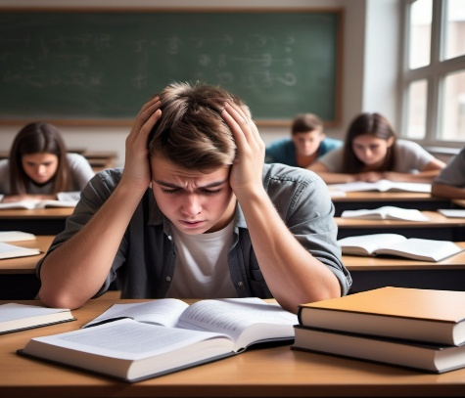 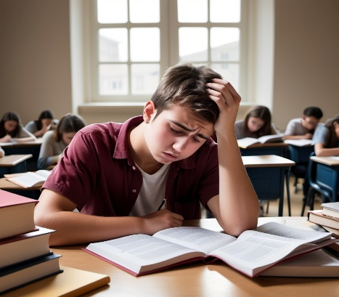

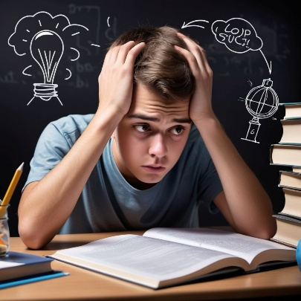

**2.By RunWay:**



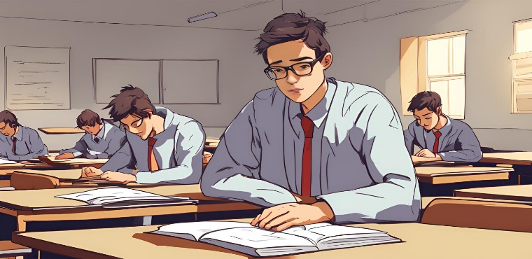



**3.By DeepDream:**

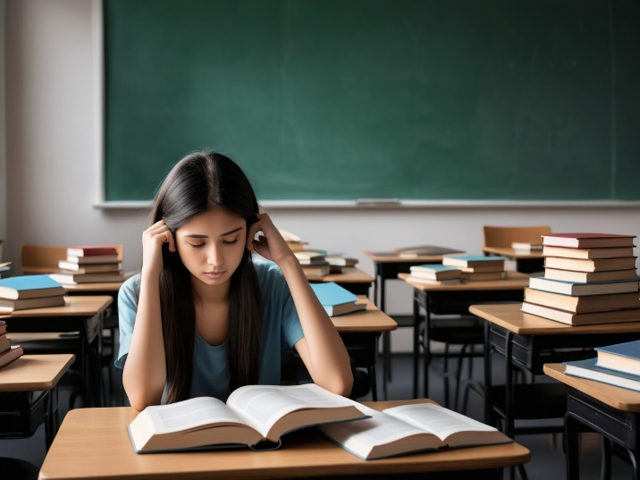

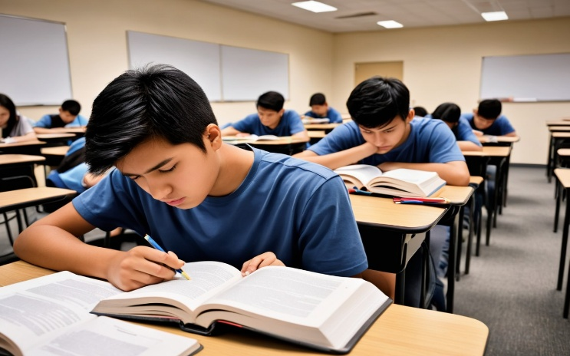

* From the above Images generated by different we can analyze that

1. **DALL E** is best suited for generating realistic or highly creative images from scratch based on a text prompt. Its use of diffusion models creates clear, polished images.
2. **Runway** is more versatile and targeted at creative professionals, offering a wide range of models for different artistic needs, including those for video and design.
3. **DeepDream**, on the other hand, is more of an artistic tool aimed at creating surreal, hallucinatory images from existing visuals. It doesn’t generate images from scratch but enhances patterns within them.

**Conclusion:**

Coming to the conclusion I felt that, DALL E is the tool that gave the images that were realistic and imaginative and the complexity was too high for it as careful tuning for best results of the images that are generated and as a result high-quality images were generated.